Using the Glasgow office staff data between 1889 and 1930, we test:

1. Whether salaries for office staff, adjusted for tenure, fell during this period
2. Whether the relationship between tenure and salaries changed over this period

We use a random effects model to estimate the relationship between time, tenure and wages during this period. The model accounts for the clustering of observations by individual. Our model is similar to that specified by Seltzer:

$$\ln\left(salary\right)=α+\sum_{j=1}^{J}{β_{j}{year}_{j}}+δ_{1}tenure+γ_{1}tenure^{2}+\sum_{k=2}^{4}{δ_{k}(period_{k}*tenure)}+\sum_{k=2}^{4}{γ_{k}(period_{k}*tenure^{2})}+u+e$$

Where $α, β, δ$ and $γ$ are all parameters to be estimated. $u$ is the random term associated with each individual and $e$ is the time varying residual term. $year_{j}$ is a dummy variable denoting the year (with baseline year being 1889). The outcome of interest, $ln⁡(salary)$ is the natural log of real salaries (as adjusted by the cost living index). $tenure$ is a variable denoting the years that a person has previously worked at Coates. Since the relationship between tenure and salaries is likely to be curvilinear, the quadratic term $tenure^{2}$ is also included. This is in line with how wages regressions are specified for data from the late 20th century (and beyond, Mincer), and is likely to be case during the late 19th and early 20th century (Seltzer). $period_{k}$ is a dummy variable denoting whether the period where $k=1,2,3,4$ refers to the years ‘1889-1900’, ‘1901-1913’, ‘1914-1918’, and ‘1919-1930’ respectively. The interaction between $period_{k}$ and $tenure$ (as well as $tenure^{2}$) allows us to estimate whether the relationship between tenure and salaries had changed over time. It should be noted that since the dummy variable $year_{j}$ is included in the model, we cannot estimate the main effects for $period_{k}$. In short, the estimates of $β_{j}$ will allow us to examine year by year changes in real salaries after adjusting for tenure. Estimates of $δ_{k}$ and $γ_{k}$ will allow us to examine changes in the relationship between tenure and salaries.

Table 1 shows the model results for male office staff. Figure 1 plots the adjusted real annual salary for a new employee at Coates over time. The plot shows that there is a noticeable drop in real earnings for office staff for every period prior to 1914. During the war this drop in real earnings increased at a greater rate until after 1918 when there was year on year increase in a real earning. The real earnings of male office staff at Coats seemed to recover to almost 1889 levels by 1930. The relationship between real earnings and tenure does seem to heavily curvilinear. In the period 1889-1900, an employee with one year of tenure is expected to earn around 20.3 per cent more than a new Coats employee. However, employees with three years tenure are only expected to earn 10.2 per cent more than those with two year tenure. One interpretation of this finding is that Coates office staff experienced very sharp increase in pay in their early years which very quickly taper off as they settle into a career at Coates. The relationship between tenure and earnings over the four periods does change. The positive relationship between $tenure$ and real earnings decreases over time whilst the $tenure^{2}$ term is tends towards zero. This suggests that over time that salary increase became more gradual instead of increases sharply at the start of one’s career at Coates. Since the model outputs can be hard to interpret, we have plotted the predicted log of real salary of an employee with one, five, and ten years tenure. For the plots, we assume that the starting salary is kept constant at one hundred pounds before tenure is taken into consideration. We use the log of salary in order to keep the graph to scale. We can see that between 1901-1913, the salary difference between those ten years tenure (green) and those with one (red) or five (blue) year tenure had grown compared to 1889-1990. The real earning differential remains at this level until after the war when these differences become greatly reduced.

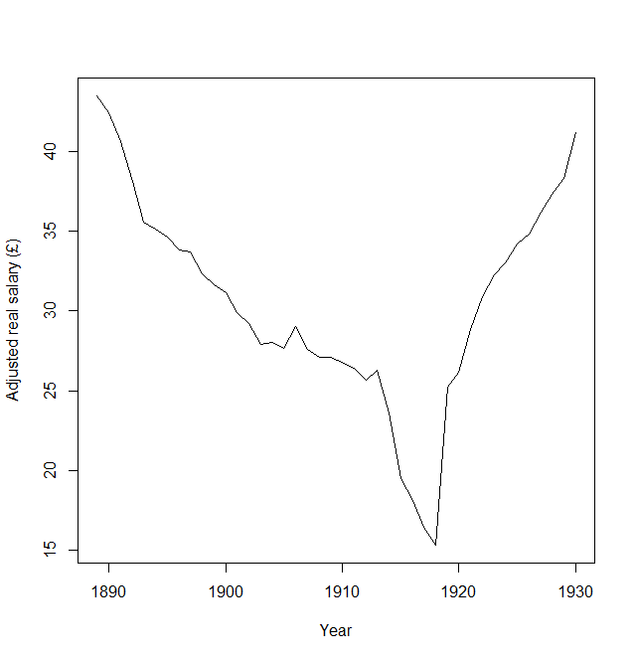

Figure Predicted salary for new Coats employee

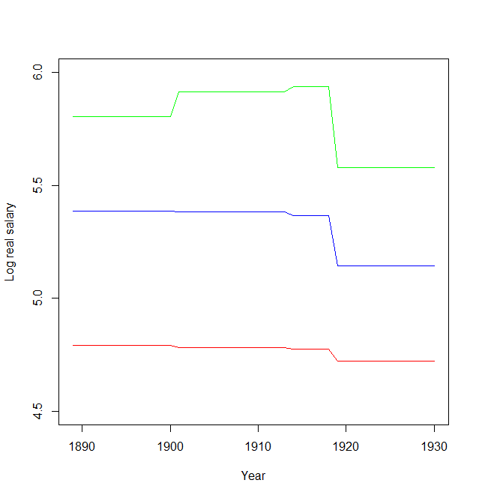

Figure Predicted log salary by tenure group: one year (red), five years (blue), ten years (green)

Table Random effects model results

|  |  |  |  |  |
| --- | --- | --- | --- | --- |
| **Random effects model of male office staff salaries (Glasgow)** | | | | |
|  | **Estimate** | **Std. Error** | **t-value** | **Pr(>|t|)** |
| (Intercept) | 3.773 | 0.036 | 103.392 | <0.001 |
| (year)1890 | -0.024 | 0.040 | -0.590 | 0.555 |
| (year)1891 | -0.068 | 0.040 | -1.709 | 0.087 |
| (year)1892 | -0.131 | 0.039 | -3.321 | 0.001 |
| (year)1893 | -0.201 | 0.039 | -5.154 | <0.001 |
| (year)1894 | -0.213 | 0.039 | -5.428 | <0.001 |
| (year)1895 | -0.228 | 0.039 | -5.776 | <0.001 |
| (year)1896 | -0.251 | 0.040 | -6.286 | <0.001 |
| (year)1897 | -0.256 | 0.039 | -6.478 | <0.001 |
| (year)1898 | -0.296 | 0.040 | -7.432 | <0.001 |
| (year)1899 | -0.319 | 0.040 | -7.892 | <0.001 |
| (year)1900 | -0.333 | 0.040 | -8.267 | <0.001 |
| (year)1901 | -0.374 | 0.039 | -9.588 | <0.001 |
| (year)1902 | -0.398 | 0.039 | -10.090 | <0.001 |
| (year)1903 | -0.445 | 0.040 | -11.204 | <0.001 |
| (year)1904 | -0.440 | 0.040 | -10.964 | <0.001 |
| (year)1905 | -0.453 | 0.040 | -11.275 | <0.001 |
| (year)1906 | -0.404 | 0.040 | -10.211 | <0.001 |
| (year)1907 | -0.456 | 0.040 | -11.509 | <0.001 |
| (year)1908 | -0.473 | 0.040 | -11.883 | <0.001 |
| (year)1909 | -0.472 | 0.040 | -11.788 | <0.001 |
| (year)1910 | -0.485 | 0.040 | -12.012 | <0.001 |
| (year)1911 | -0.499 | 0.041 | -12.291 | <0.001 |
| (year)1912 | -0.527 | 0.041 | -12.913 | <0.001 |
| (year)1913 | -0.504 | 0.041 | -12.286 | <0.001 |
| (year)1914 | -0.611 | 0.042 | -14.501 | <0.001 |
| (year)1915 | -0.803 | 0.043 | -18.617 | <0.001 |
| (year)1916 | -0.878 | 0.044 | -19.837 | <0.001 |
| (year)1917 | -0.974 | 0.046 | -21.396 | <0.001 |
| (year)1918 | -1.043 | 0.047 | -22.348 | <0.001 |
| (year)1919 | -0.545 | 0.040 | -13.461 | <0.001 |
| (year)1920 | -0.508 | 0.040 | -12.545 | <0.001 |
| (year)1921 | -0.412 | 0.041 | -10.147 | <0.001 |
| (year)1922 | -0.341 | 0.041 | -8.401 | <0.001 |
| (year)1923 | -0.299 | 0.041 | -7.313 | <0.001 |
| (year)1924 | -0.275 | 0.041 | -6.705 | <0.001 |
| (year)1925 | -0.240 | 0.041 | -5.826 | <0.001 |
| (year)1926 | -0.222 | 0.041 | -5.369 | <0.001 |
| (year)1927 | -0.184 | 0.042 | -4.414 | 0.000 |
| (year)1928 | -0.152 | 0.042 | -3.625 | 0.000 |
| (year)1929 | -0.127 | 0.042 | -3.007 | 0.003 |
| (year)1930 | -0.054 | 0.043 | -1.273 | 0.203 |
| tenure | 0.192 | 0.005 | 39.769 | <0.001 |
| (tenure^2) | -0.007 | 0.000 | -18.111 | <0.001 |
| 1901-1913:tenure | -0.012 | 0.005 | -2.394 | 0.017 |
| 1914-1918:tenure | -0.021 | 0.006 | -3.625 | 0.000 |
| 1919-1930:tenure | -0.074 | 0.005 | -14.399 | <0.001 |
| 1901-1913:(tenure^2) | 0.002 | 0.000 | 5.786 | <0.001 |
| 1914-1918:(tenure^2) | 0.003 | 0.000 | 8.322 | <0.001 |
| 1919-1930:(tenure^2) | 0.005 | 0.000 | 12.865 | <0.001 |